**AWS Task-1**

Create a windows Vm machine in AWS and connect with RDP open CMD in windows share the about system info.

Launch instance AWS console



Get the key pair .pem file

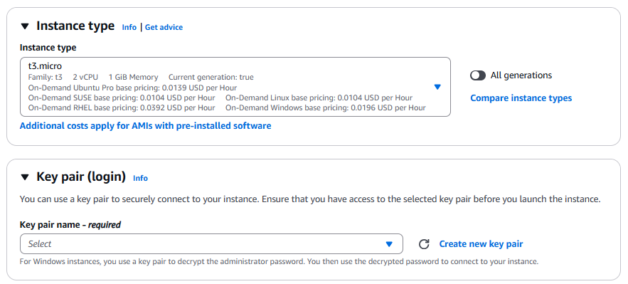

Connect windows instance in AWS

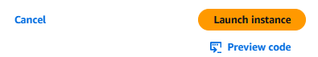

Select the instance and click connect and select RDP client, download rdpclient file to launch the RDP

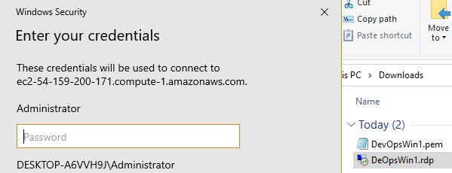

Get the password from the AWS portal for RDP client



Map/Upload the .pem file and click decrypt password,

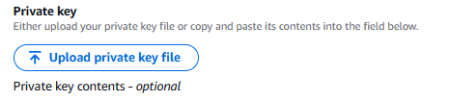

Use the password and connect to the instance, share systeminfo output

